Renju lesson on March 29, 2001

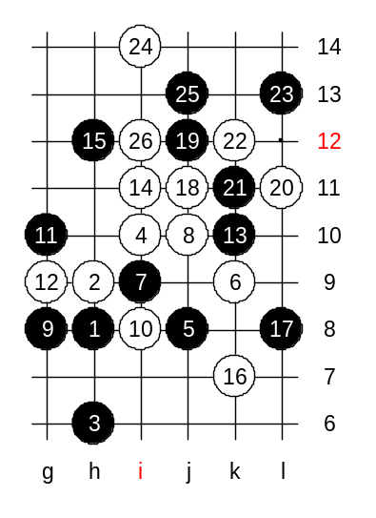
Hello all! Welcome to Online Renju Class. Today we will continue with d11 opening. Today we will study another 5th move – 5-j8. Does anyone know, what is the conclusion about that 5th move? In 1990, in one of the international tournaments, I used this move as black. Indeed, at that time the theory was not so well developed, and I could win that game. About a year or two later, some people proved white win. Where is the winning 6th move? 6-k9 is correct. The following moves are quite complicated and you need to have full attention to understand the essence of those moves. Both black and white have some material on the board. The first thing is, we check if black has VCT. Does black have VCT? If no, then check what can black do so that white cannot win after that and yet black can keep some activity. Usually, in such situations, in case of absence of win, the black and white materials neutralize each other. Usually neutralizing begins with active moves, such as threes, fours. G10 – black uses waiting style. G10 seems possible, because black is quite active, and white does not have VCT. What is the 12th move for white and why? White cannot attack now. And therefore white chooses a block that neutralizes black activity and makes white attack alive again. G9!
Now black is in trouble. Black’s counter-attack material is dead, and white is looking good. 13-k10 – black has no choice but continue passive defense. Here are two ways to win now. Two different concepts. I will show you one style first, then another. 16-k7 is the only win move here. Now white has two winning areas. It seems white wins. Lets try L8. Where is win now? Good, many of you found it.

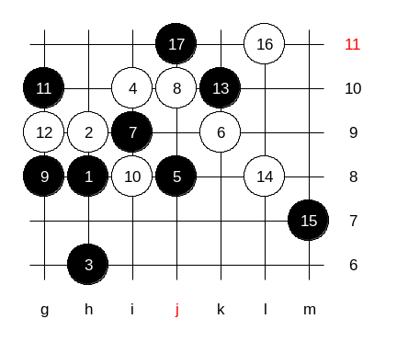
Now we will try the other style of white attack. L8. What happens if black blocks the three from upper side? Then white will play L7 – the strongest development move with complete control. Therefore, black must defend below.

After 16th move white has sure win position.
This is the medium level homework. Please find the white win.

Now, it is about the time to learn about the most important 5th move in d11 opening. We will study the 5th move that people play every day, everywhere in the world.
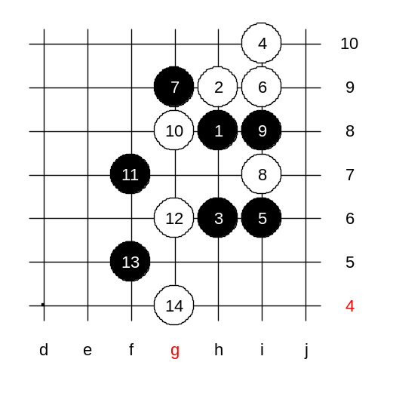
It is 5-i6. White’s 6-i9 is the only move. Does anyone know if this 5th move gives white or black advantage? There is no conclusion now. We do not know whether it is good for black or white now. There are two recently discovered variants, and they are unclear and need further research. 8-i7 – we begin with a little bit untraditional 8th move. You need to know several side variants too, when you learn about openings. It is quite meaningless to follow the main path up to 20th move without checking any side variants. If we do not know side variants, then opponents may easily surprise us. How many of you know the black win here after such 8th move? Now, you see, because of small different in sequence compared to main path f the opening, here black can defend below, f7. Now, after the strongest 12-g6, how can black continue?
Indeed, f5 is correct, can anyone explain why? We played f5 because despite the two attacking areas, each area alone is not enough for win. So we use f5 to sacrifice one of two sides, and make another side stronger.
This is the advanced level homework. Please find the black win.

